
SKY R580 DATA SHEET

Sky Microwave Co., Ltd
Features:  Up-to-date sensor with doppler radar technology  Non-touch module with strong capability against RF interference and wrong alarm.  Low cost & Low Power Consumption.  Pin Type & ROHS (Pb Free).\  Small and Flat Profile.  Reliable Construction & High Sensitivity.  Application:  Traffic/highway observation and control  Security product (sensing device, alarm etc)  Automobile rear sensing  Automatic door  Sensing light  Possible to apply to all product by working with sensor | 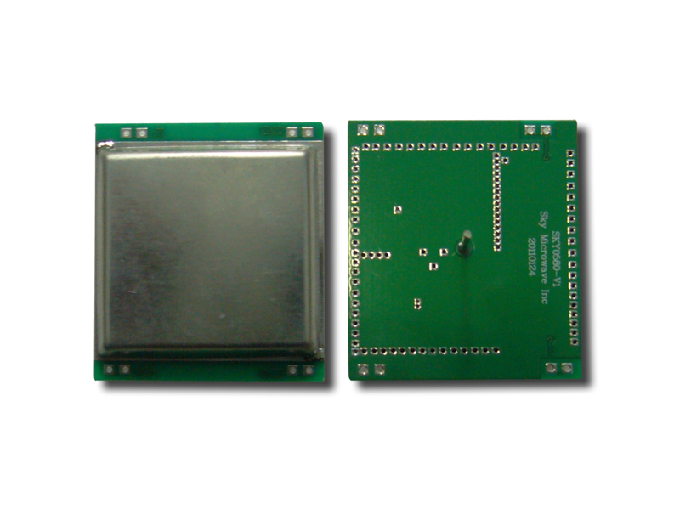
Specification:
Center frequency ------ 5.8GHz
Operating voltage ------ DC 7V ~ 20V
Operating current ------ 6mA maximum.
High / low output level ------ 5V / 0V
3dB antenna pattern ------ 180 deg. Nom. E-plane
------ 180 deg. Nom. H-plane
Sensing distance ------ 0.3 ~ 15 meters 16 stages adjustment
Triggering mode ------ 4 options
Pulse width--------------20μs with 1ms duty cycle
Operating temperature range ------ -30 ~ +55℃
Storage temperature range ------ -40 ~ +80℃
Dimensions ------ 40.8mm*36.3mm*15mm(not including antenna)

Important note: We are original manufacturer in this microwave sensor module!
Package Size and Weight:
Carton size: 36x 39 x66cm /Quantity: 1000pcs/Carton/ N.W:20kgs/CN/ G.W.:21kgs/CN

